Field of diversity: | 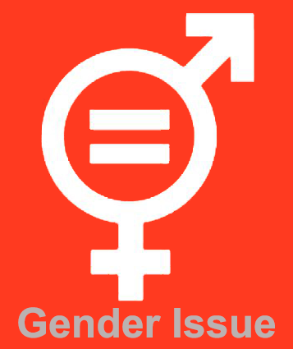 |  | 83 BEFL |  | Group size:
Title | Swapping genders
Content | Think about the implications of changing your gender |  |  |  | Time: 30 minutes
Goals (Skills/Competences) | To understand social expectations related to sex and gender  To acknowledge similarities and differences between people  To acknowledge the influence of gender related messages
Material | Hand-out to copy. Exercise sheet. Attachment with possible solutions.
Procedure: | Let participants answer the following question: “imagine you would be of the opposite sex. What aspects of your life would be different? In the past, the present and the future?” Give some suggestions like relationships with your parents, your siblings, friends, partners, job choice, leisure time, clothing, being a parent…  Let every participant work individually for 5 minutes. Ask to form small groups, preferably all male/female. Ask them to compare their answers and write down a summary.  Discussion: Go over the answers. What do men/boys see as possible changes? Ask for feedback from the women/girls. What do women/girls see as possible changes? Ask for feedback from the men/boys. Is the general sense in the answers rather positive or negative? Is there a gender difference in the answers?
Modifications
Comments
Success  factors |  | Pitfalls
The activity is flexible and depends on the local context. Feel free to adapt!
©
UDEL 21

