Field of diversity: | 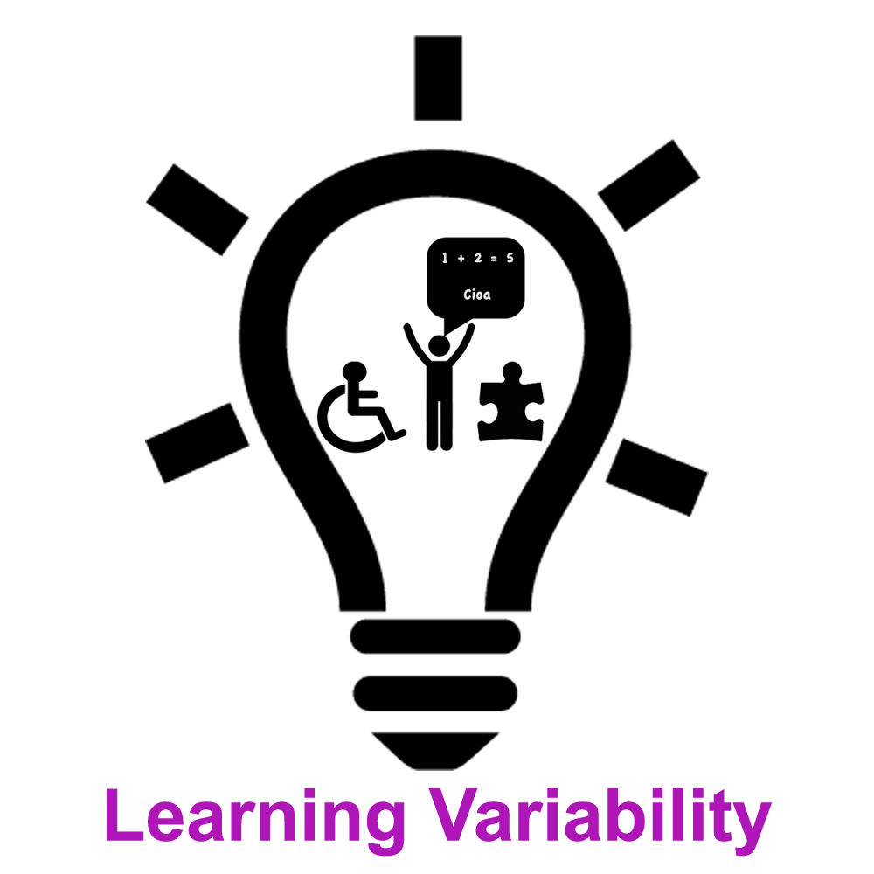 |  | CZ  53 |  | Group size:
Title | Exploring Learning Needs
Content | Pupils move according teacher´s instruction in response to questions about their preferences in the process of learning. |  |  |  | Time: 15-25 min
Goals Skills/Competences | Identification of needs that pupils have regarding their learning, better understanding of diversity in the society. Pupils understand their needs and preferences in the process of learning.
Material | Space for movement
Procedure: | - Teacher introduces the topic of the lesson (diverse needs regarding effective learning). Teacher asks pupils to form the line from one wall to another in the space of classroom where there are no chairs and tables. The line will represent scale to express the needs regarding learning (positions on the far ends of the scale represent strong need, position in the middle represents no significant preference of given choices). Teacher explains that pupils will change position on the scale according to given instructions.  - Teacher asks “Who needs more to listen to learn something goes to the left side of the scale (it is good to use additional information to help pupils realise what they need such as lectures and discussions are better ways of learning than reading from the book or visual presentations; when the lecture is missed it is harder to learn from the textbook; repeating aloud or in a whisper helps you to remember information etc.) and who needs more to see information to learn goes to the right side (visual information such as pictures, graphs, schemas and patterns are more useful than lectures; when trying to remember some information from the text book you clearly see where the information was placed and how it was structured etc.). You can also go to the middle when you have no significant preference of given sensory inputs and you use both equally.  - Teacher then asks one or more pupils from far ends of the scale and from the middle to describe his/her needs regarding learning. Teacher continues with other questions e.g Who needs to move during studying (who needs walking or manipulating thinks or frequent regular brakes for physical exercise to concentrate better) goes to the left, who needs to sit or lie still (and moving from the place would reduce concentration) goes to the right.
Modifications
Comments
Success  factors |  | Pitfalls
The activity is flexible and depends on the local context. Feel free to adapt!

