Field of diversity: | 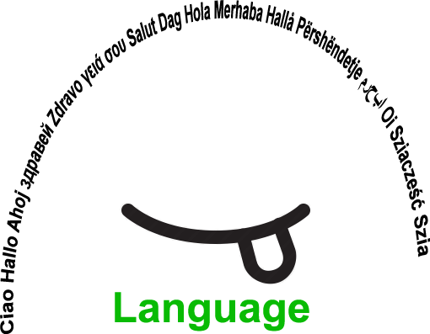 |  | 38  BEFL |  | Group size:  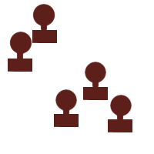 (groups of 4)
Title | Placemats
Content | A group with great variety (e.g. newcomers) that learn the basics on democracy using multilingualism. |  |  |  | Time: 40 minutes
Goals (Skills/Competences) | Students can express and defend their opinion and search together for a compromise
Material | Papers (A3) that can be used as placemats with 4 sections and 1 middle part. Markers or big pens.
Procedure: | - For 3’ students write down in their own language (mother tongue) some ideas to take to the students board  - For 10’ they explain to each other what they have written. This time they use the same language – for Flanders this will be Dutch – newcomers are helped by other students, speaking their language and translating their ideas  - For 5’ they look for similarities and write down one proposal in the middle field of the placemat  - They present their proposal to the entire group, other team members can participate, argument on the proposals  - The group decides on 1 or 2 proposals to take to the students board
Modifications
Comments
Success  factors | Thinking goes faster in the mother tongue, so gathering ideas in the mother tongue can make the discussion that follows even richer | Pitfalls |  | If the timing is not respected: students get bored or uninterested
The activity is flexible and depends on the local context. Feel free to adapt!
©
UDEL 21

