Field of diversity: | 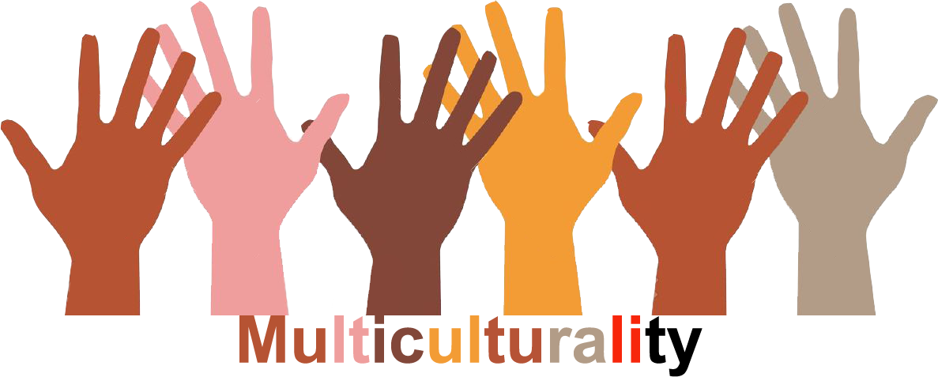 |  | 19  AT |  | Group size:  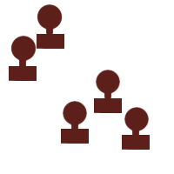
Title | Stop sign – it is okay to be different
Content | Discussion about diversity in a multicultural society |  |  |  | Time: 1 UE
Goals (Skills/Competences) | Work with people from different cultural backgrounds. Find solutions to avoid differences. The group excludes nobody, they see the diversity as »normal«. Self confidence and social competences are reinforced.
Material | »Stop« sign, Tape measure, Questions for the discussion
Procedure: | -Teacher attaches a stop sign and a large reference point to the classroom door.  - The pupils discuss the significance or meaning of the stop sign and reference point with the teacher before they enter the classroom.  - Anyone smaller than the reference point is not allowed to go into the classroom and must stay in the corridor with the teacher (group A).  - Anyone as tall as or taller than the reference point is allowed into the classroom (group B). (A second teacher is required so that both groups are supervised!)  - After a while the teachers ask the question, »Is it actually fair that not everybody is allowed into the classroom?«  -Both groups try to find solutions without breaking or adapting the rules (e.g. no tables, chairs, ...) Teachers' instructions: find solutions to get all the children into the classroom. (Of course the teacher must have solutions prepared in order to determine how many different possible solutions the children have to come up with!)  - After solutions have been found – children sit all together in a circle for feedback round.  - How did the children outside feel?  - Do you think it is fair when others are excluded? (for example just because they are small, ...)  - Have you ever been excluded?  - What could society, the class, you as an individual do, to make sure nobody is excluded?
Modifications  Comments | different references: length of hair, language, colour of clothes, glasses, shoes, ......
Success  factors | The class should be familiar with rules of debate, it is a good idea to discuss or to practise the rules before the activity. The rules must be clearly defined by the teacher and discussed with the children. | Pitfalls |  | Do not use references that the children cannot fulfil or that only very few of them can fulfil. Do not ask for more possible solutions than I can think of myself!

